Paper Folding

The idea of this activity is to use paper folding to build intuition about multiplication, division, and factoring. Students learn how to fold strips of paper into 2 and 3 equal parts and then discover that they can make any other number that is a multiple of 2's and 3's by combining folds.

- Ask students to draw a line down the middle of a strip of paper, dividing it into two equal parts. How can you check to be sure it is exactly in the middle? Help students see that when you fold a piece of paper so that the edges match up exactly, then the two parts are exactly the same size.

- Same with 3 equal parts. Draw 2 lines that divide the strip into three equal parts. Then, check by folding. This is much harder because you have to fold the two ends in at the same time.

- At this point some students will take off and invent their own configurations. For example, they will fold into thirds as suggested above, then fold in half to get sixths. The teacher can help the students see, for example, that you get six parts because six has a factor of 3 and a factor of 2. It is important that they understand the connection between the number of parts they get and the factors of this number. Otherwise they will than simply fold randomly and then count.

We can even begin to generalize at this step. For example, the teacher can help students see that no matter how many folds you’ve done previously, a “double fold” is going to double the number of parts.

- Students should reach the point where they can then plan ahead: How can we make 9 equal parts? A “three-fold” and then another “three-fold.” Have the students try the following folds:

2
3
4 = 2 x 2
6 = 2 x 3
8 = 2 x 2 x 2
9 = 3 x 3
12 = 2 x 2 x 3
16 = 2 x 2 x 2 x 2

Extensions / issues that may arise:

Can we fold a strip of paper into 11 equal parts? Why is that so much harder than 6, 8, or 12?

Folding a square rather than a strip: Given a suggestion, students will quickly see that they can fold a square both 'vertically' and 'horizontally' into 2 or 3 equal rectangles. Can we fold a square into 16 smaller squares? How? Can we fold a square into 9 smaller squares? What other numbers work?

Folding a square is harder than folding a strip of paper because the folds will go different ways. So for example, we can fold a square into four rectangles, by folding in half vertically, then in half again vertically. This produces four 'striplike' rectangles. Or we could fold it in half vertically, then in half horizontally, to get four smaller squares.

Ask students to discuss, “Why do three double-folds make 8?” After all, 2 + 2 + 2 is 6.

Students can also be asked if, any straight line fold that passes through the center of the square will create two equal areas. In fact it does. This may not be obvious.



Students can also be asked if a straight line crease that divides the square into equal areas must go through the center of the square. This is a difficult question, both geometrically and logically. Logically, we are asking about the converse of the statement above. Many students will not easily see the difference between these two statements:

(a) If a line passes through the center of the square, then it divides it into halves.
(b) If a line divides the square into halves, then it must pass through the center of the square.

It is enough simply to get students to see the difference between these statements. In this case the converse is true, but not every converse of a true statement is true. It is rare that students understand this subtlety from one example. But they may begin to distinguish the two statements. Examples like “If I live in Dallas then I live in Texas” (suitably adapted to your area) may help.

But the problem is difficult geometrically as well. Advanced students might be able to compare a line not passing through the center with a parallel line through the center. The latter creates halves. But a comparison with the former will reveal that the part to the left is either larger or smaller than half.

As with most geometry situations, it is important to tie the visual discovery to a reasoning process.

As another extension, give students paper squares and have them think of different ways to fold the square so that the resulting figure is half the area of the original square. (There are many, many interesting ways, and the variety will give students a better intuition of what “half” means.) For example, it is possible to fold a square into the following shapes, each exactly half the area of the original square: a triangle, a square, a rectangle, a parallelogram, and a pentagon. (See photo below.)

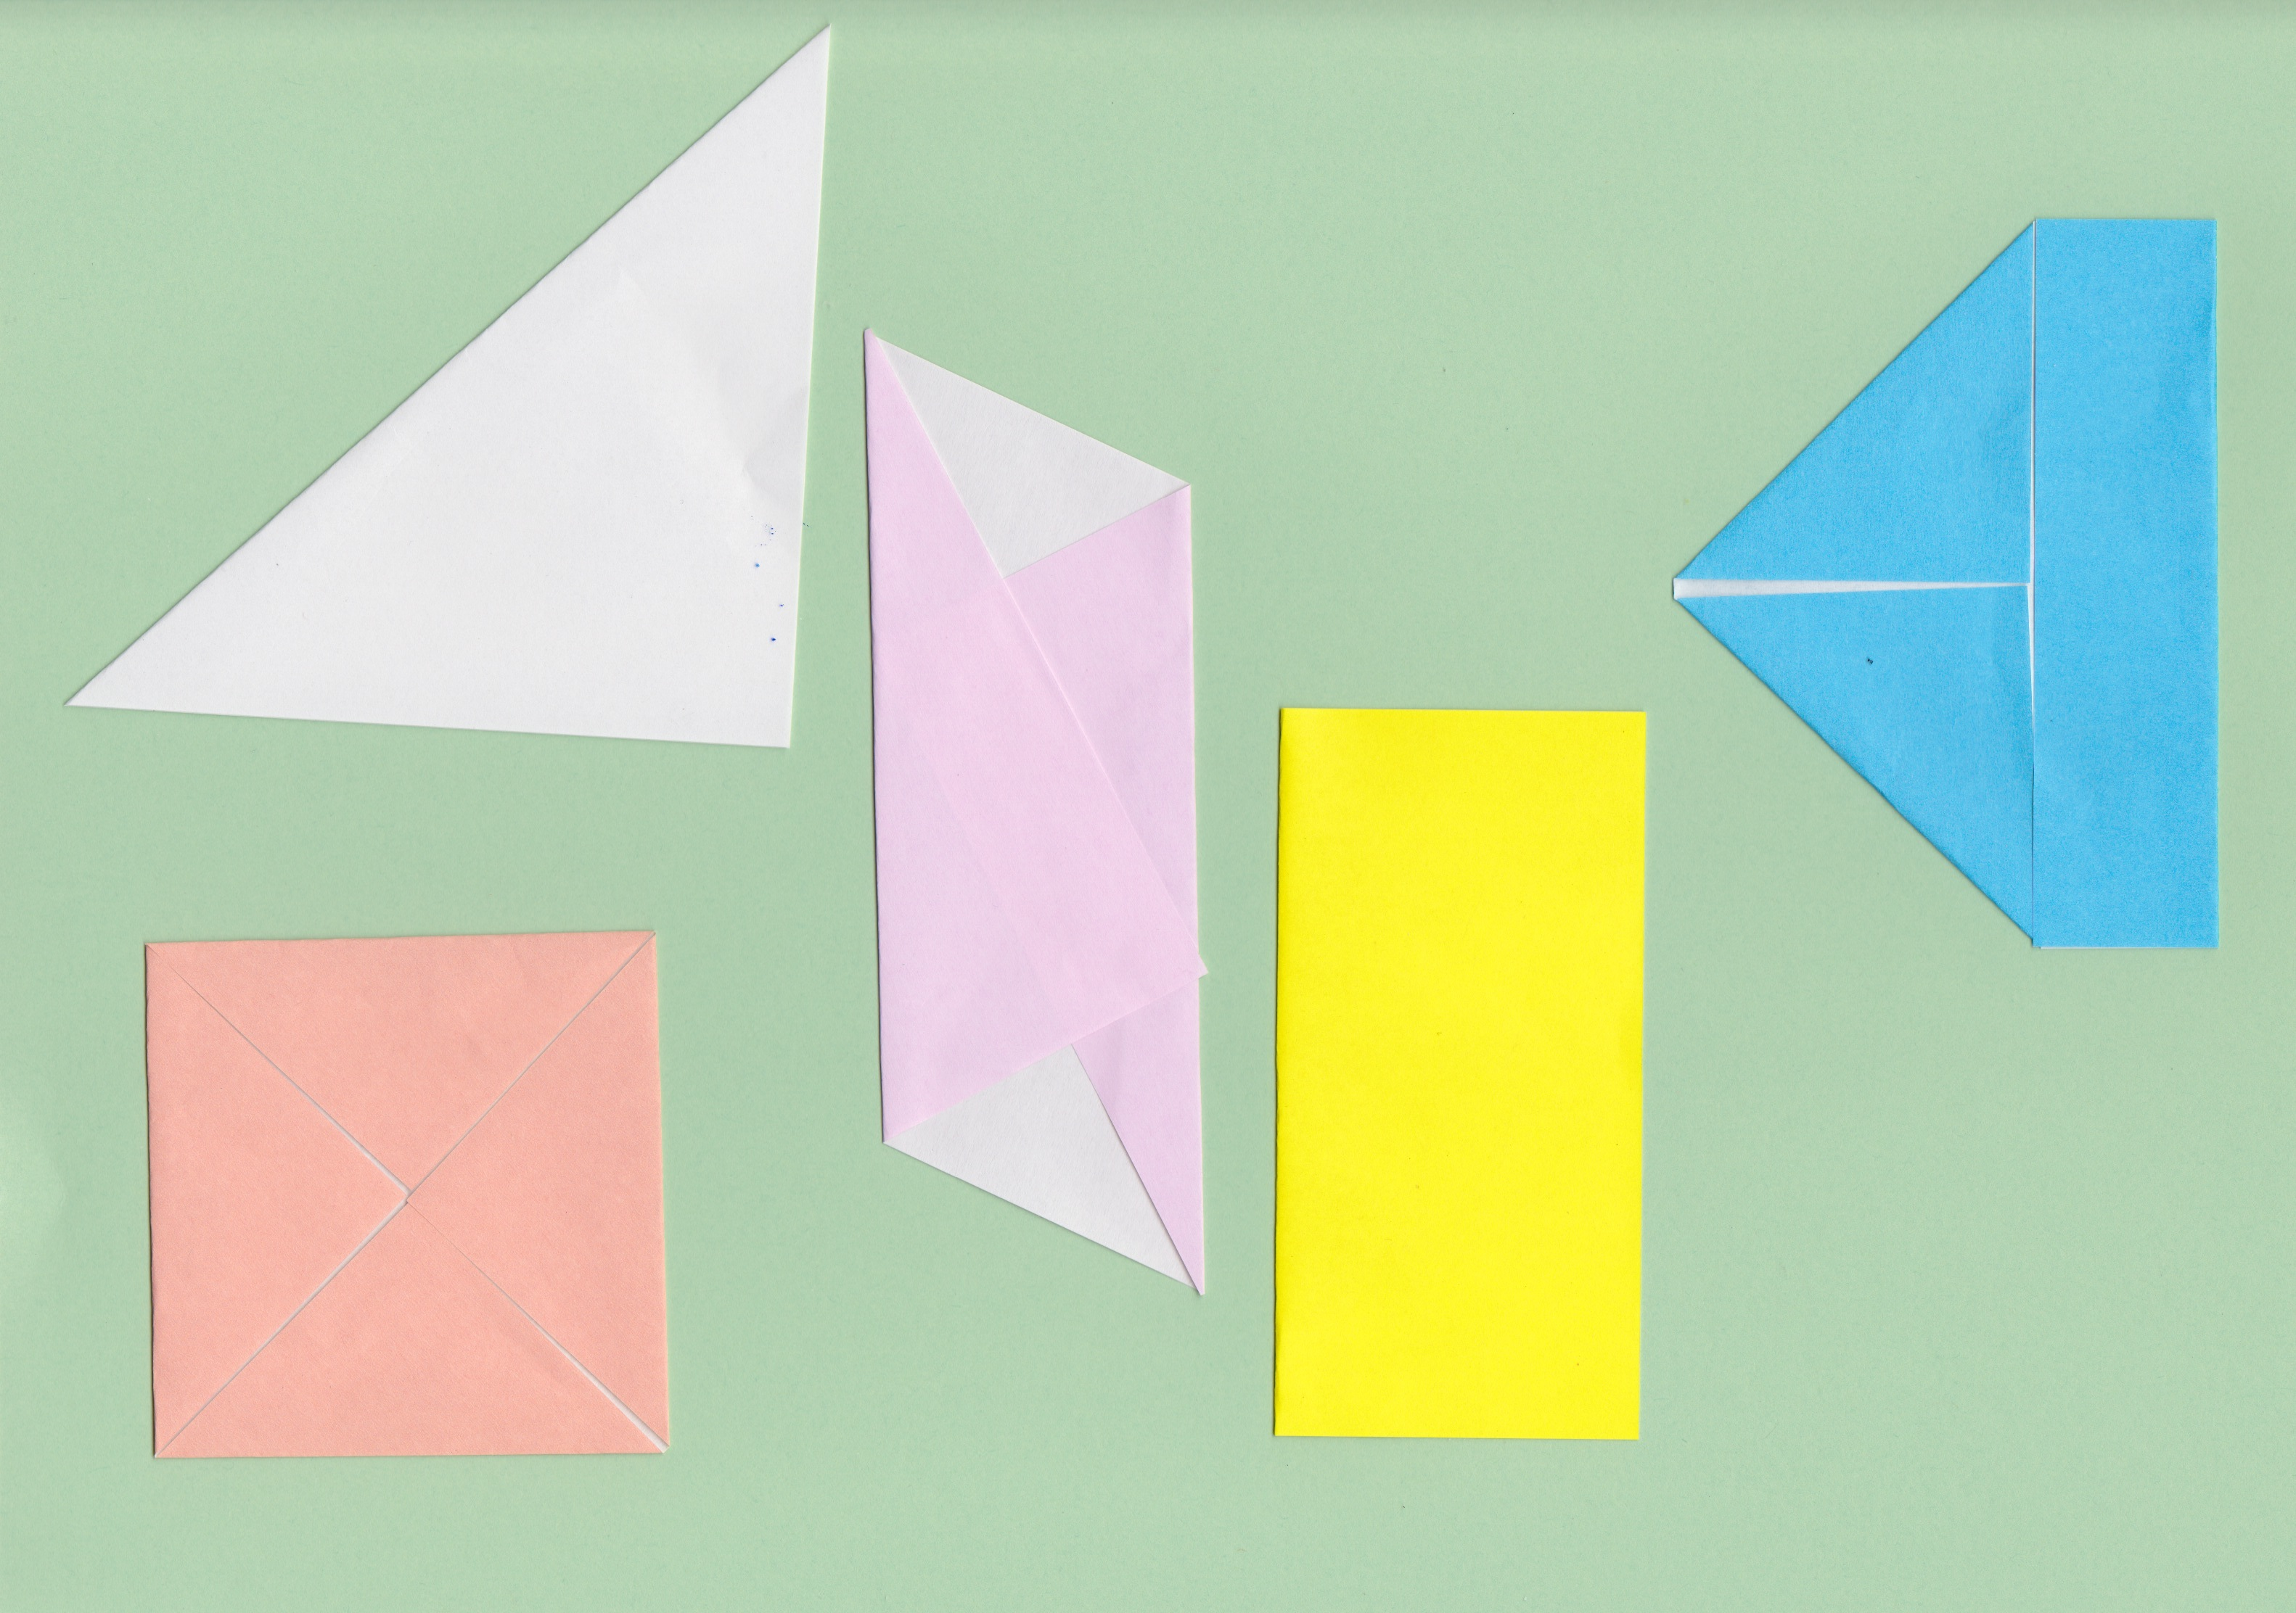

Once students create a folding, ask them to explain how they know its area is half of the original square. Students’ answers will vary depending on their experience with formal geometry. A simple explanation in some cases is that the two halves fit exactly on top of each other, so they must be the same size. With the parallelogram below, on the other hand, students need a more sophisticated argument. They may see that each of the two folded triangles is half the area of the parallelogram (because each has the same base and same height as the parallelogram). If the two triangles and the parallelogram together form a square, then the parallelogram must have half the area of the square.



